Mutual information: NZDUSD and EURGBP
Method 15 / daily log returns / B=10 equal-frequency bins / Alpari D1 full available history

Study setup
Logical pair: NZDUSD , EURGBP
Broker symbols: NZDUSD_i , EURGBP_i
Snapshot: 2026-11-03_majors_alpari_D1
Timeframe: D1
Matched return window: 1999-01-06 to 2026-11-02 (UTC bar dates)
Matched return count n: 7183
Dropped unfinished last bar dated 2026-11-03 UTC after a tick-volume check against the prior complete day.
Discretization: B=10 equal-frequency bins per leg
Units: nats (natural log)
Complete matched rows (Excel): NZDUSD-EURGBP_MI_D1.xlsx
Complete matched rows (HTML table): NZDUSD-EURGBP_MI_D1_data.html

Method carried forward
Mutual information I(X;Y) measures shared information between matched daily log returns of close, ln(close_t / close_t-1), after a fixed discretization. Quotes are not inverted. Each leg is cut into B=10 equal-frequency (decile) bins using that leg's matched-sample quantiles. Discrete MI uses natural log (nats): I = sum p_ab ln(p_ab / (p_a p_b)). Marginal entropies H_x and H_y and normalized MI = I / sqrt(H_x H_y) are stored for comparison. Bin count is not tuned after seeing pair rankings. Same-sample Pearson r is a side check only. This is not causation, lead-lag, or a trading signal.

Results
I(X;Y): 0.016446 nats
Normalized MI: 0.007142
H_x: 2.302585
H_y: 2.302585
Same-sample Pearson r: 0.037186

Conclusion
Over 7183 matched daily rows for NZDUSD and EURGBP with B=10 equal-frequency bins, I(X;Y) = 0.016446 nats (normalized MI = 0.0071; H_x=2.3026, H_y=2.3026). Same-sample Pearson r is 0.0372. This does not establish cause, lead-lag, or a lasting trading rule.

Charts
Daily closes

Daily log returns

Joint bin-count heatmap
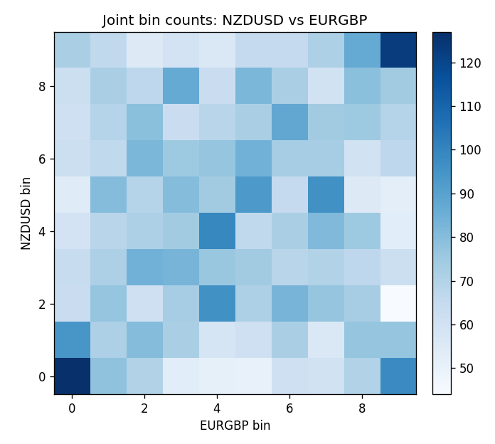

Data report
Every matched row that entered MI is stored in the sibling Excel workbook named NZDUSD-EURGBP_MI_D1.xlsx, including bin labels. Embedding all rows as a Word table is impractical; this file holds column summaries and the first and last 15 matched rows.
Columns: time, NZDUSD_open, EURGBP_open, NZDUSD_high, EURGBP_high, NZDUSD_low, EURGBP_low, NZDUSD_close, EURGBP_close, NZDUSD_tick_volume, EURGBP_tick_volume, NZDUSD_spread, EURGBP_spread, NZDUSD_real_volume, EURGBP_real_volume, NZDUSD_log_return, EURGBP_log_return, NZDUSD_bin, EURGBP_bin
Column summaries (matched calculation rows)
column | count | mean | std | min | 25% | 50% | 75% | max
NZDUSD_open | 7183 | 0.65646991 | 0.10818219 | 0.3913 | 0.591455 | 0.6684 | 0.72495 | 0.88218
EURGBP_open | 7183 | 0.78694248 | 0.0966971 | 0.5734 | 0.68755 | 0.83389 | 0.86522 | 0.9769
NZDUSD_high | 7183 | 0.66038812 | 0.10867344 | 0.3961 | 0.5949 | 0.67204 | 0.729365 | 0.88421
EURGBP_high | 7183 | 0.7900202 | 0.09707133 | 0.5789 | 0.6896 | 0.8369 | 0.8681 | 0.9799
NZDUSD_low | 7183 | 0.65278196 | 0.10777661 | 0.3897 | 0.58816 | 0.6642 | 0.720985 | 0.87988
EURGBP_low | 7183 | 0.78424251 | 0.0965143 | 0.5682 | 0.6855 | 0.83166 | 0.86287 | 0.9661
NZDUSD_close | 7183 | 0.65654354 | 0.10817679 | 0.3907 | 0.59181 | 0.6685 | 0.72502 | 0.8822
EURGBP_close | 7183 | 0.78698724 | 0.09669475 | 0.5735 | 0.68775 | 0.83395 | 0.86536 | 0.977
NZDUSD_tick_volume | 7183 | 68736.568 | 123152.54 | 16 | 5594.5 | 33901 | 58513.5 | 1127682
EURGBP_tick_volume | 7183 | 87133.158 | 145499.84 | 154 | 6553 | 44358 | 81413 | 1424684
NZDUSD_spread | 7183 | 30.260755 | 25.633067 | 0 | 9 | 17 | 40 | 80
EURGBP_spread | 7183 | 21.328832 | 19.122264 | 0 | 4 | 13 | 40 | 50
NZDUSD_real_volume | 7183 | 1.6708354e+10 | 8.49951e+10 | 0 | 0 | 0 | 0 | 2.705649e+12
EURGBP_real_volume | 7183 | 2.7872287e+10 | 1.3521454e+11 | 0 | 0 | 0 | 0 | 3.5726265e+12
NZDUSD_log_return | 7183 | 1.073e-05 | 0.0076464 | -0.07027433 | -0.00425909 | 0.00022967 | 0.00458236 | 0.05966839
EURGBP_log_return | 7183 | 2.33e-05 | 0.00487088 | -0.03067367 | -0.00262163 | -9.879e-05 | 0.002558 | 0.06075387
NZDUSD_bin | 7183 | 4.5006265 | 2.8724812 | 0 | 2 | 5 | 7 | 9
EURGBP_bin | 7183 | 4.5006265 | 2.8724812 | 0 | 2 | 5 | 7 | 9
First 15 matched rows (selected columns)
time | NZDUSD_close | EURGBP_close | NZDUSD_log_return | EURGBP_log_return | NZDUSD_bin | EURGBP_bin
1999-01-06 | 0.5383 | 0.7019 | 0.0020455609 | -0.013303338 | 6 | 0
1999-01-07 | 0.5417 | 0.7097 | 0.0062963171 | 0.011051402 | 8 | 9
1999-01-08 | 0.5414 | 0.7062 | -0.00055396548 | -0.004943862 | 4 | 1
1999-01-11 | 0.547 | 0.7053 | 0.010290425 | -0.0012752393 | 9 | 3
1999-01-12 | 0.5441 | 0.7077 | -0.0053157489 | 0.0033970309 | 2 | 8
1999-01-13 | 0.5387 | 0.708 | -0.0099742238 | 0.00042381861 | 0 | 5
1999-01-14 | 0.5386 | 0.7066 | -0.00018564931 | -0.0019793588 | 4 | 3
1999-01-15 | 0.5382 | 0.7012 | -0.00074294208 | -0.0076715819 | 4 | 0
1999-01-18 | 0.5372 | 0.7017 | -0.0018597736 | 0.00071280921 | 3 | 5
1999-01-19 | 0.5382 | 0.7007 | 0.0018597736 | -0.0014261269 | 6 | 3
1999-01-20 | 0.5404 | 0.7021 | 0.0040793678 | 0.0019960086 | 7 | 7
1999-01-21 | 0.5426 | 0.7016 | 0.0040627941 | -0.00071240297 | 7 | 4
1999-01-22 | 0.5361 | 0.7004 | -0.012051689 | -0.0017118406 | 0 | 3
1999-01-25 | 0.5342 | 0.6966 | -0.0035504102 | -0.0054402425 | 2 | 1
1999-01-26 | 0.5381 | 0.6962 | 0.0072741158 | -0.00057438255 | 8 | 4
Last 15 matched rows (selected columns)
time | NZDUSD_close | EURGBP_close | NZDUSD_log_return | EURGBP_log_return | NZDUSD_bin | EURGBP_bin
2026-10-13 | 0.56127 | 0.84458 | 0.0047326165 | 0.00020130374 | 7 | 5
2026-10-14 | 0.55918 | 0.84553 | -0.0037306483 | 0.0011241873 | 2 | 6
2026-10-15 | 0.56185 | 0.84479 | 0.0047634855 | -0.00087557391 | 7 | 4
2026-10-16 | 0.56509 | 0.84307 | 0.0057501001 | -0.0020380844 | 8 | 3
2026-10-19 | 0.56616 | 0.84259 | 0.0018917133 | -0.00056950988 | 6 | 4
2026-10-20 | 0.56827 | 0.83957 | 0.0037199341 | -0.0035906254 | 7 | 1
2026-10-21 | 0.57003 | 0.83839 | 0.0030923331 | -0.00140647 | 6 | 3
2026-10-22 | 0.56815 | 0.83682 | -0.0033035227 | -0.0018743924 | 2 | 3
2026-10-23 | 0.56991 | 0.83751 | 0.0030929853 | 0.00082421033 | 6 | 5
2026-10-26 | 0.56826 | 0.83762 | -0.0028993932 | 0.00013133309 | 3 | 5
2026-10-27 | 0.56811 | 0.83595 | -0.00026399852 | -0.0019957343 | 4 | 3
2026-10-28 | 0.56261 | 0.83651 | -0.0097283914 | 0.00066967224 | 0 | 5
2026-10-29 | 0.56296 | 0.83553 | 0.00062190714 | -0.0011722209 | 5 | 3
2026-10-30 | 0.56307 | 0.83351 | 0.00019537668 | -0.0024205543 | 4 | 2
2026-11-02 | 0.56161 | 0.83426 | -0.0025962955 | 0.00089940465 | 3 | 6

